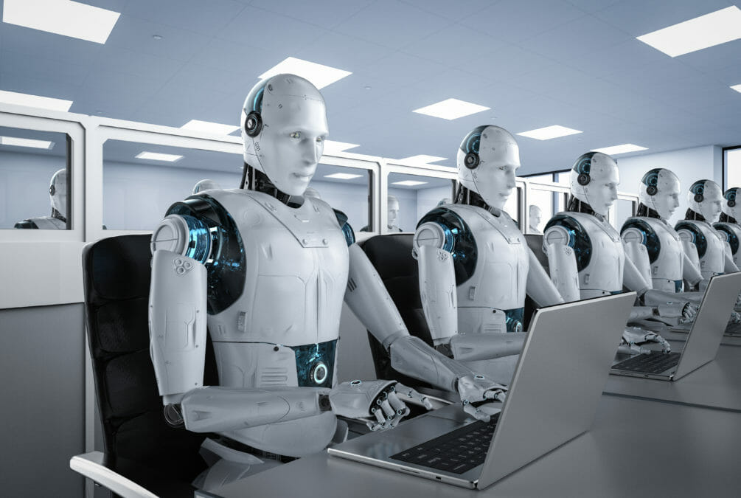­­­­­

|  |  |
| --- | --- |
|  |  |



Coronavirus worldometer

Table of Contents

I. INTRODUCTION 4

1.1 Purpose 4

1.2 Objectives 4

1.3 Key Contacts 5

II. AS IS Process description 5

2.1 Process Overview 5

2.2 Applications Used 7

2.3 AS IS Process Map 7

2.3.1 High Level Process Map 8

2.3.2 Detailed Level Process Map 8

2.4 Process Statistics 8

2.5 Detailed As Is Process Actions 9

2.6 Exceptions Handling 9

2.7 Input Data Description 10

III. TO BE Process description 11

3.1. Detailed TO BE Process Map 11

3.3. In Scope For RPA 12

3.5. Exceptions Handling 12

3.7. Reporting 14

# INTRODUCTION



## Purpose

The Process Definition Document outlines of the process that will be automated. The document describes the sequence of actions performed as part of the business process

**The PDD is a communication document between:**

* The RPA Business Analyst and the SME/Process Owner. The goal is to ensure that the RPA Business Analyst has the correct understanding of the process and has represented it accurately.
* The goal is to ensure that the process is documented appropriately and to a sufficient level of detail so that the Solution Architect can then create the solution based on the PDD content.

## Objectives

The business objectives and benefits expected by the Business Process Owner after automation of the selected business process are:

* Reduce time
* Make the process mor accurate without Human mistakes

## Key Contacts

|  |  |  |  |
| --- | --- | --- | --- |
| Role | Name | Contact Details (email, phone number) | Notes |
| B.A | Hady Abdelaleem | hadyabdelaleem@gmail.com | Non |
| Developer | Hady Abdelaleem | hadyabdelaleem@gmail.com | Non |

# AS IS Process description

## Process Overview

**Section contains general information about the process before automation**.

|  |  |
| --- | --- |
| Item | Description/Answer |
| Process Full Name | Coronavirus worldometer |
| Process Area | Corona Virus Statistics Searching |
| Department | Healthcare |
| Short Description (operation, activity, outcome) | Simply you will search by country name about corona Virus and print Results to User |
| Role(s) required in applications to perform the process | RPA Developer |
| Process schedule and frequency | Daily |
| Number of times the process is ran by selected frequency | 100 |
| Process execution time | 30.7 sec. |
| Process Restrictions | Non |
| Peak Period (s) | **Monday** |
| Peak Volume Approximate increase | 20% margin Added as increase in Volume to be 120 |
| Number of persons performing the process | 1 |
| Expected Volume increase during next periods | ***20%*** |
| Percentage Un-handled exceptions | 0% |
| Input data description | ***Country Name*** |
| Output Data description | **Print in Log message**  Coronavirus Cases  Deaths  Recovered |

## Applications Used

The table includes a comprehensive list of all the applications that are used as part of the process to be automated to perform the given actions in the flow.

|  |  |  |  |  |  |
| --- | --- | --- | --- | --- | --- |
| Application Name | Version | Application Language | Thin/Thick Client | Environment/ Access method | Comments |
| Web Browser |  | **EN** | ______ | ______ | ______ |

## AS IS Process Map

In this section all process will be described in details

### High Level Process Map

.

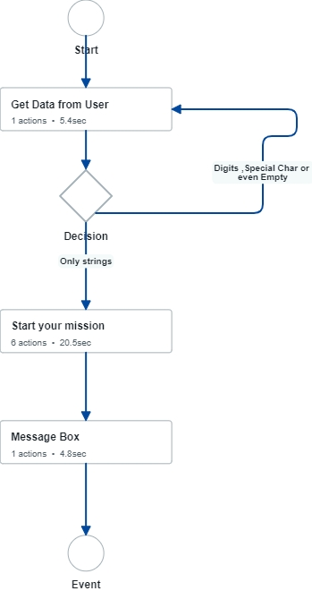

### Detailed Level Process Map

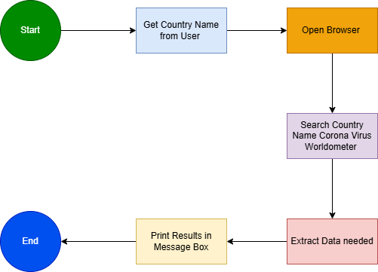

## Process Statistics

**High Level statistics**

|  |  |  |  |  |  |  |  |
| --- | --- | --- | --- | --- | --- | --- | --- |
| Processes | Windows | Actions | Mouse clicks | Keys pressed | Text entries | Hotkeys used | Time |
| 2 | 6 | 8 | 8 | 0 | 0 | 0 | 30.7 sec. |

**Detailed statistics**

|  |  |  |  |
| --- | --- | --- | --- |
| Window name | Mouse clicks | Text entries | Key pressed |
| Corona Search | 1 | 0 | 0 |
| Message Box | 1 | 0 | 0 |
| Google - School - Microsoft​ Edge | 1 | 0 | 0 |
| Google and 1 more page - School - Microsoft​ Edge | 1 | 0 | 0 |
| Egypt coronavirus worldometer - Google Search and 1 more page - School - Microsoft​ Edge | 1 | 0 | 0 |
| Egypt COVID - Coronavirus Statistics - Worldometer and 1 more page - School - Microsoft​ Edge | 3 | 0 | 0 |
|  |  |  |  |
|  |  |  |  |

## Detailed As Is Process Actions

|  |  |  |  |  |  |
| --- | --- | --- | --- | --- | --- |
| #Action | Input | Description | Details (Screen/Video Recording Index) | Exceptions Handling | Possible Actions |
|  |  |  |  |  |  |
|  |  |  |  |  |  |

|  |  |
| --- | --- |
| 1. Get Data from User | |
|  | **Est. time: 5.4 sec.** |

|  |  |
| --- | --- |
| * 1. Input Dialog |  |
|  | Est. time: 5.4 sec. |
| image | Create Input Dialog To get the Country Name from User |

|  |  |
| --- | --- |
| 1. Decision | |
| If 'Digits, Special Char or  even Empty' then go to '1. Get Data from User' And ask User again  If 'Only strings' then go to '3. Start your mission' | **Est. time: 0.0 sec.** |

|  |  |
| --- | --- |
| 1. Start your mission | |
|  | **Est. time: 20.5 sec.** |

|  |  |
| --- | --- |
| * 1. Open Browser |  |
| Open Bowser and open google | Est. time: 0.2 sec. |
| image | Open Bowser and open google |

|  |  |
| --- | --- |
| * 1. Search for information |  |
|  | Est. time: 1.2 sec. |
| image | Type into Search Bar (Country Name) +  "Coronavirus worldometer " |

|  |  |
| --- | --- |
| * 1. Enter the Frist Web site Link |  |
| Enter the Web site to get information | Est. time: 4.2 sec. |
| image | Action: Click  Enter the Web site to get information |

|  |  |
| --- | --- |
| * 1. Get text |  |
| Get Corona virus Cases | Est. time: 11.9 sec. |
| image | **Get Corona virus Cases** |

|  |  |
| --- | --- |
| * 1. Get text |  |
| Get Death | Est. time: 1.6 sec. |
| image | **Get Death** |

|  |  |
| --- | --- |
| * 1. Get text |  |
| Get Recovered | Est. time: 1.5 sec. |
| image | **Get Recovered** |

|  |  |
| --- | --- |
| 1. Message Box | |
|  | **Est. time: 4.8 sec.** |

|  |  |
| --- | --- |
| * 1. Data presenting |  |
|  | Est. time: 4.8 sec. |
| image | Print Data in Structed Form |

|  |  |
| --- | --- |
| 1. Event | |
| End | **Est. time: 0.0 sec.** |

## Exceptions Handling

1. If the input Data from User (Country Name ) is not String -> thin ask him again to reinter Country Name
2. If there are No Internet connection Stop the Robot and tell User to Establish the Internet Connection

## Input Data Description

The Only input is the Country Name and You will take it from User

# TO BE Process description

## Reporting

|  |  |  |  |
| --- | --- | --- | --- |
| Report Type | Update frequency | Details | Monitoring Tool to visualize the data |
| *e.g Process logs* | ***e.g.*** *Monthly* | ***e.g.*** *How many robots worked on this process per each month?* | ***e.g.*** *Csv file posted daily on share drive* |

* For complex reporting requirements, include them into a separate document and attach it to the present documentation

# Thanke You

.

